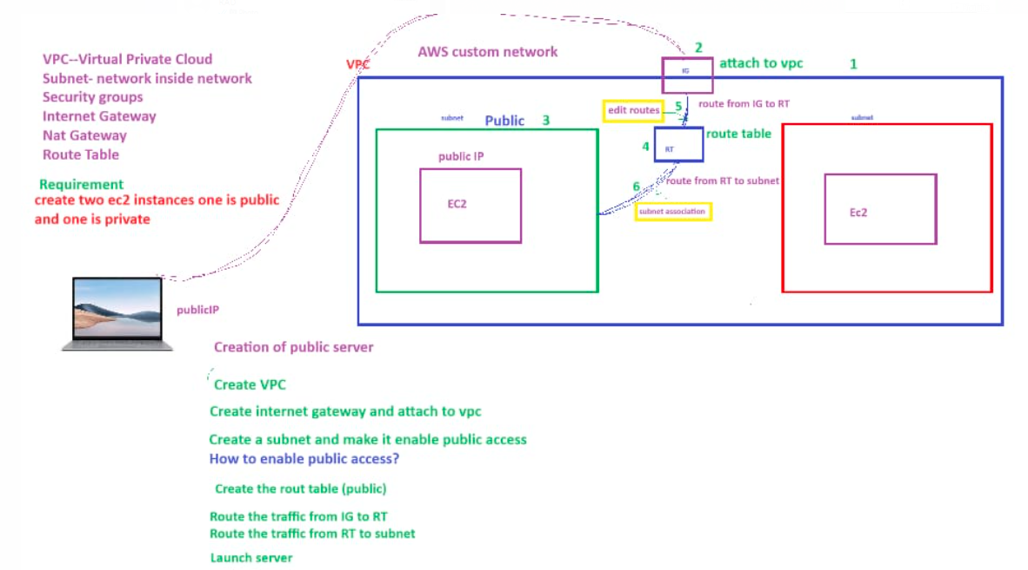

NOTE: To connect the private server from externally, here we should require public server mandatory.

Internet Gateway (IG)

By using the IG the request will goes out and comes in

Route table (RT)

It is used to route the traffic from IG to subnet.

BY using edit route option, we can route traffic from IG to RT.

BY using subnet association, we can route traffic from RT to subnet.

CIDR (classes less inter domain range or routing).

VPC size will be depends on CIDR range.

IPV4

1 byte=8 bits

Octet or byte

